Uzbekistan’s Small Business in the Era of AI Agents and Demographic Change
Analytical Review of Trends for the Third Quarter of 2026
September 2026

1. Introduction
The third quarter of 2026 sent entrepreneurs two important signals. On the one hand, Uzbekistan’s economy is growing at one of the fastest rates in the world, and over the summer international organizations raised their forecasts for the current year one after another. On the other hand, global research from this period shows that artificial intelligence is no longer a novelty and has become an everyday working tool, yet only a small share of companies are capturing real financial returns from it. For small businesses, this means new opportunities and new demands on management at the same time.
This review has been prepared for entrepreneurs and small business owners. It summarizes the findings of reports published between June and September 2026 by the international consulting firms McKinsey, Boston Consulting Group, KPMG, PwC, and Bain & Company, and by research centers and business publications, including the Copenhagen Institute for Futures Studies, Harvard Business Review, and MIT Technology Review, as well as data from the International Monetary Fund (IMF), the World Bank, the European Bank for Reconstruction and Development (EBRD), the Asian Development Bank (ADB), and the Central Bank and the National Statistics Committee of the Republic of Uzbekistan.
The review focuses on three themes that, according to most sources, will have the strongest impact on small businesses in the coming years. The first theme is artificial intelligence (AI) and AI agents, that is, software that can not only answer questions but also carry out chains of actions on its own. The second theme is corporate transformation, meaning the redesign of processes, roles, and ways of making decisions. The third theme is demography, which determines who the customers and employees of the coming decade will be. The material moves from the general to the specific. It first examines global trends, then the regional context and the situation in Uzbekistan, and concludes with practical recommendations.

2. Key Takeaways of the Quarter
The first takeaway concerns artificial intelligence. Nearly nine in ten organizations worldwide use it regularly, yet only 37% report any impact of AI on operating profit, and only about 6% of companies achieve a significant effect. The gap is explained not by the limits of the technology but by the fact that most companies embed AI into old processes without changing them.
The second takeaway concerns small businesses. Over the past year, the share of large organizations scaling AI agents rose from 27% to 40%, while among smaller organizations it remained at 22%. If small businesses do not start adopting new tools in a deliberate way, their productivity gap with large players will keep widening.
The third takeaway concerns Uzbekistan’s economy. Gross domestic product (GDP) grew by 8.5% in the first half of 2026, and full-year growth forecasts range from 6.4% to 8.1%. At the same time, the Central Bank’s policy rate remains at 14% with inflation at 6.2%, so money remains expensive for businesses and projects need to pay for themselves quickly.
The fourth takeaway concerns demography. According to preliminary census results, the country’s population has exceeded 39 million, of whom 12.5 million are below working age. A young, urban, and increasingly digital consumer, together with migrant workers’ remittances, which reached $9.3 billion in the first half of the year, is shaping the demand around which small businesses should build their products.

3. World. Artificial Intelligence and AI Agents in Business
The main shift of 2026 is that the debate about artificial intelligence has moved from whether to adopt it to how to get a return from it. A McKinsey study published in late August shows that nearly nine in ten organizations regularly use AI in at least one business function. However, only 37% of respondents attribute any increase in operating profit to AI, and this share has not changed over the year. Companies that attribute at least 5% of their operating profit to AI and describe its contribution as significant account for only about 6% of the sample. In other words, the technology has gone mainstream, while tangible results from it remain rare.
A BCG survey of nearly 12,000 employees of companies in more than a dozen countries paints a similar picture. Some 74% of frontline employees already use AI regularly, and 42% of them save at least eight hours a week, which amounts to a full working day. The share of those whose workflows include AI agents rose over the year from 13% to 30%. At the same time, the authors stress that the time saved often fails to translate into additional value for the business if management has not decided how it should be used. This is the source of the conclusion reflected in the study’s title, namely that strategy matters more than tools.
A KPMG survey of 1,750 transformation leaders from 20 countries confirms that the problem is managerial in nature. Only 26% of respondents strongly agree that AI has helped their companies achieve their growth objectives. The main obstacles to a return on AI investment are high implementation costs and unclear payback (29%), followed by data infrastructure problems (23%) and a shortage of skilled specialists (22%). Agentic AI has already moved beyond IT departments and is used in marketing and sales at 43% of companies, in operations at 42%, and in finance at 33%.
Figure 1. Share of organizations scaling AI agents in 2025 and 2026, %
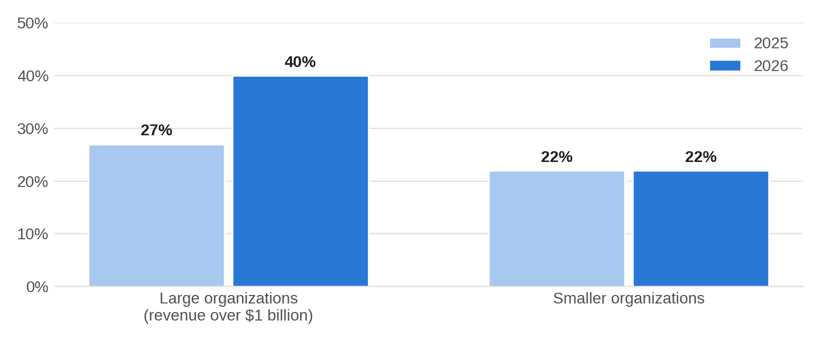
Source — McKinsey & Company, The state of AI in 2026, August 2026.
The question of what actually counts as an AI agent deserves special attention. Analysts at Yakov & Partners reviewed 18 products positioned as global leaders in the AI agent market, and only 7 of them passed a test against six criteria of agency. The rest turned out to be assistants of varying sophistication that are called agents for marketing purposes. Of 43 public projects to deploy agents at large companies, only 10 reached the level of a fully fledged agent, and more than half of the solutions are used in internal processes rather than in customer-facing work. The authors describe a “fading cascade” effect, in which a single task is completed 55% faster under laboratory conditions, yet the effect at the level of the whole company turns out to be zero if the surrounding processes are not redesigned.
The second practical problem relates to costs and security. About 20% of respondents in the McKinsey survey admitted that the costs of running AI constrain its use. According to KPMG, 53% of US companies already use AI agents, yet only 26% have real-time visibility into the costs of running AI. In its technology report released in late September, Bain & Company notes that AI has cut the time needed to prepare a typical cyberattack from about four weeks to 18 hours. For small businesses, this means that the risks of fraud, phishing, and forged payment documents are growing faster than before.
AI is also changing the labor market. According to PwC, productivity at the companies most exposed to AI is growing 40% faster than at the least exposed ones. The wage premium for AI skills has reached 62%, and the number of job postings requiring such skills grew by 69%, compared with 9% growth in job postings overall. Drawing on data from the Stanford Digital Economy Lab and ADP, MIT Technology Review notes that there is no convincing evidence yet of AI-driven unemployment, but in occupations highly exposed to AI, such as software developers and customer service agents, jobs for entry-level specialists are becoming scarcer. The Copenhagen Institute for Futures Studies calls this phenomenon the “missing junior loop,” because the path of a young specialist toward professional experience is becoming steeper.
A separate area of importance for retail and services is agentic commerce, in which an AI agent selects a product, places the order, and pays for it on the buyer’s behalf. McKinsey estimates that by 2030 AI agents could put between $75 billion and $160 billion of global payments revenue at risk, because they will automatically choose the most advantageous cards, accounts, and payment methods.

4. World. Corporate Transformation
The second global trend concerns how companies themselves are changing. KPMG finds that transformation is not yet delivering the expected results, not because of a lack of ambition or investment, but because most organizations keep adding change initiatives without redesigning how work is organized. Only 14% of companies consider themselves top performers relative to their peers. According to respondents’ self-assessment, the largest performance gains come from risk transformation (+14%), digital and technology transformation (+9%), and business model transformation (+8%).
According to KPMG, leaders stand out because they first build technology foundations and data capabilities, embed risk controls and responsible AI directly into processes, organize work around creating value for the customer rather than around departments, and make employee learning a permanent part of work. McKinsey reaches the same conclusion, noting that the companies getting the most value from AI do not simply add it to existing processes but redesign those processes end to end, and set goals for AI not only in cost savings but also in revenue growth. Bain puts the same idea differently, arguing that the main advantage is no longer access to technology but the speed at which a company is able to absorb it.
In its September–October issue, Harvard Business Review proposes treating transformation as a learning journey rather than as an engineering project with a rigid plan. Using the example of Singapore’s DBS Bank, the authors show that successful change unfolds as a series of waves in which the lessons of the first pilot projects set the priorities for the next ones. Another article in the issue stresses that AI is becoming ubiquitous as a technology but remains rare as a capability embedded in data, processes, and speed of execution. Companies that buy AI as an ordinary commodity merely raise the bar for the whole market without gaining an advantage of their own. A third article describes the next step, in which AI agents coordinate decisions across procurement, logistics, finance, and sales, although even Walmart and Amazon are only at the beginning of this path.
These findings have direct practical relevance for small businesses. It is easier for a small company than for a large corporation to redesign a process end to end, because it has fewer layers of approval and fewer departments, and the owner personally sees the entire customer journey. This is precisely where the opportunity lies to narrow the gap with large players discussed above.

5. World. The Demographic Shift
In its megatrends review published in September 2026, the Copenhagen Institute for Futures Studies identifies the inversion of the population pyramid as one of the fundamental forces of long-term change. The world’s population is projected to grow to 10.3 billion by the mid-2080s, yet more than a quarter of humanity already lives in countries where the population has peaked, including China, Germany, Japan, and Russia. The global average fertility rate has fallen to about 2.3 children per woman, which is less than half the level of the 1950s.
The consequences of this shift differ from country to country. Aging economies face labor shortages and invest in automation and AI to offset the shrinking workforce. Countries with young populations face the opposite task and are looking for ways to provide productive employment for a rapidly growing number of young people. According to the authors, where this succeeds, a country reaps a demographic dividend, and where it fails, unemployment, informal employment, and migration pressure increase. The number of international migrants worldwide reached 304 million in 2024, almost twice as many as in 1990.
Demography is directly linked to AI. The authors of the review describe two possible scenarios. In the first, competition for young workers becomes a subject of bargaining between states, and in the second, automation and AI replace a significant share of jobs, and labor shortages prove less acute than expected. For a country with a young population such as Uzbekistan, both scenarios mean that the skills and productivity of young workers become the main condition for growth.

6. Region. Central Asia and Russia
The World Bank expects global growth to slow to 2.5% in 2026, and against this backdrop Central Asia remains one of the most dynamic regions. In its September report, the EBRD projects that the economies of Central Asia and Mongolia will grow by 5.8% in 2026 and by 5.3% in 2027. The bank names weaker demand in Russia and China and high energy prices as the main external risks.
AI adoption in the region is uneven. A KPMG study covering large companies in the Caucasus and Central Asia found that 53% of them use AI in their operations with measurable impact, compared with a global average of 24%. However, Kazakhstan’s official statistics paint a different picture for the economy as a whole, as only 3.4% of the 152,000 reporting enterprises used AI in 2025. Comparing these figures shows that large companies in the region are already actively adopting AI, while small and medium-sized businesses are at the very beginning of the journey. For entrepreneurs in Uzbekistan, this is both a warning and a window of opportunity, since the first companies to master AI in their niche gain a noticeable advantage.
The Russian market, which is closely linked to Uzbekistan’s through trade, migration, and digital platforms, shows similar dynamics. Yakov & Partners estimates that the Russian market for corporate AI agents and assistants will reach about 30 billion rubles in 2026, yet it still has no fully fledged off-the-shelf AI agents. The best examples have been built in-house by large companies rather than purchased from vendors. In July 2026, Russia adopted a law on supporting the development of AI technologies, whose main provisions take effect in stages starting September 1, 2026, with labeling rules following from March 1, 2027. Entrepreneurs working with Russian partners and platforms should bear in mind that requirements for the models used and for AI-generated content in neighboring countries will become stricter.
The regional labor market is changing too. According to Migration Agency data cited in a Central Bank of Uzbekistan review, about 1.4 million citizens of Uzbekistan work abroad in nearly 40 countries, including about 834,000 in Russia. At the same time, the number of labor migrants in CIS countries fell by 29%, while in Europe it rose by 42%. The geography of labor migration is gradually shifting toward higher-paying markets, and this is changing the income structure of households that receive remittances.

7. Uzbekistan. An Economy of Fast Growth and Expensive Money
Uzbekistan’s economy is growing faster than expected in 2026. According to the National Statistics Committee, GDP grew by 8.5% in the first half of the year to reach 1,072.7 trillion soums. Growth for 2025 as a whole was 7.7%. All major international organizations raised their 2026 forecasts over the summer. The World Bank expects growth of 6.4%, the IMF about 6.8%, the Asian Development Bank 7.0%, the EBRD 7.5%, and the Eurasian Development Bank (EDB) 7.9%, while the government has raised its own forecast to 8.1%. The differences are largely explained by publication dates, as estimates made after the half-year data were released fall within the 7–8% range.
Figure 2. Uzbekistan’s GDP growth forecasts for 2026 and actual growth in the first half of 2026, %
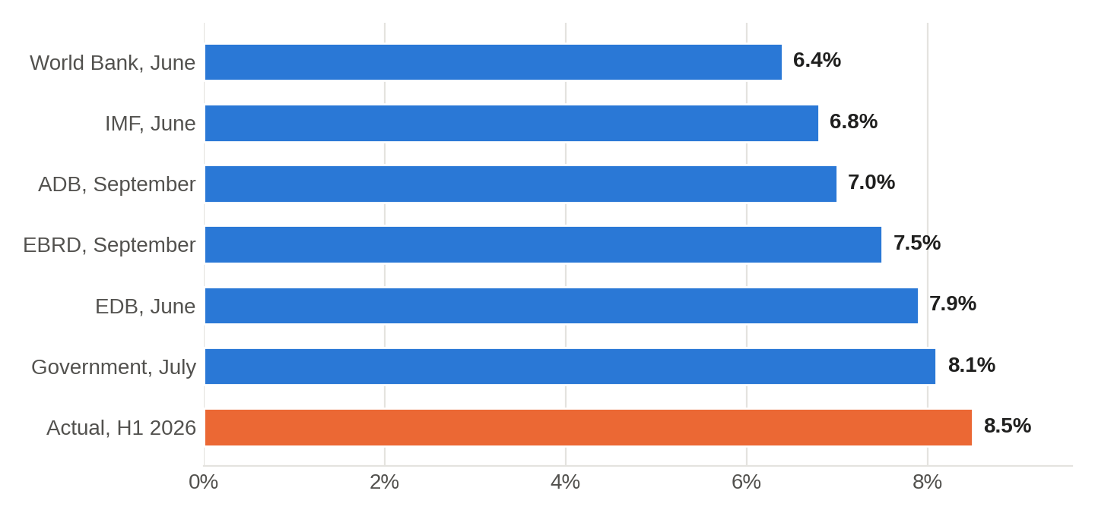
Source — World Bank, IMF, ADB, EBRD, EDB, Ministry of Economy and Finance, National Statistics Committee of the Republic of Uzbekistan.
Strong growth is accompanied by tight monetary policy. On September 16, 2026, the Central Bank kept its policy rate at 14% per annum, while annual inflation in August stood at 6.2% and core inflation at 5.5%. The ADB forecasts inflation at 6.7% for 2026. The gap between the policy rate and inflation remains substantial, so loans for small businesses will stay expensive at least until the end of the year, even if the regulator begins to lower the rate gradually.
Small businesses play a key role in the country’s economy. According to official statistics, they accounted for 52.2% of GDP in 2025 and 50.5% of GDP in the first half of 2026. Their share of total employment in 2025 was 74.9%. Comparing these figures points to the sector’s main structural problem. Small businesses provide jobs for three quarters of the employed population but generate only about half of value added, which means that labor productivity in the sector is substantially lower than in large companies. That is why productivity tools, including AI and process digitalization, are especially important for small businesses in Uzbekistan.
An additional driver of change will be accession to the World Trade Organization (WTO). At the WTO Working Party meeting on July 27–28, 2026, Uzbekistan reaffirmed its goal of completing accession in 2026, and some 190 legal acts have been aligned with WTO rules since March. For small businesses, this means more open competition with imports on the one hand, and more predictable rules and new export opportunities on the other.

8. Uzbekistan. Demography, Migration, and the Consumer
The preliminary results of the population census were among the top news stories of the quarter. As of January 15, 2026, the country had 39,047,321 residents, which is 810,617 people, or 2.1%, more than previous estimates. Urban residents make up 54.5% of the population. The working-age population numbers 21.7 million, while 12.5 million people, or almost a third of the population, are below working age.
Figure 3. Age structure of Uzbekistan’s population according to the preliminary results of the 2026 census, million people
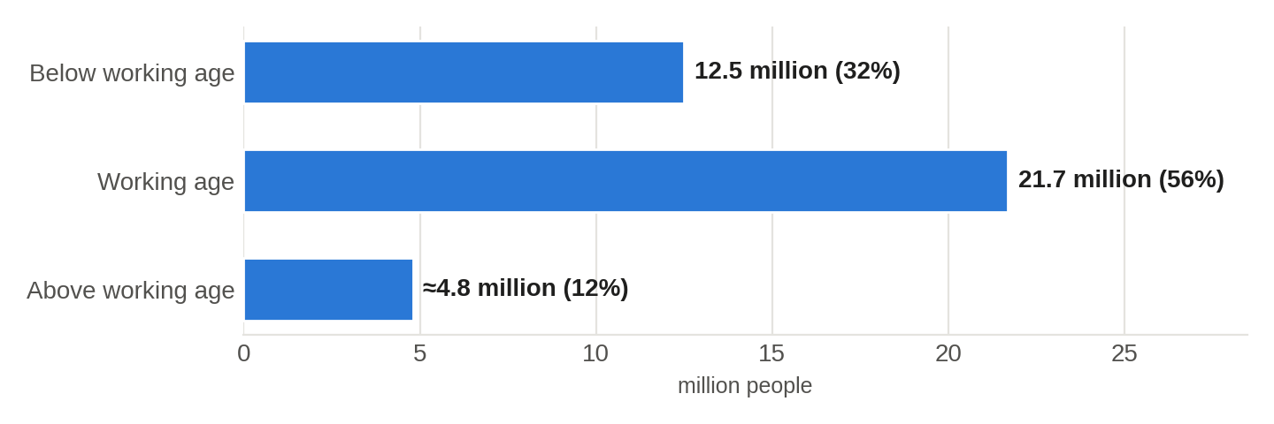
Source — preliminary results of the 2026 population census. The population above working age is calculated as the difference between the total population and the other two groups.
This structure means that in the coming decades Uzbekistan will remain one of the youngest countries in the region, unlike aging Russia and China. Around 600,000 young people enter the labor market every year, and according to the country’s leadership, this number may approach one million by 2030. For small businesses, this means access to a large pool of young workers and, at the same time, the need to train them, since, as PwC and MIT Technology Review data show, even entry-level positions increasingly require AI skills, independence, and the ability to communicate with customers.
Remittances remain the most important source of consumer demand. In the first half of 2026, they reached $9.3 billion, up 13% from the same period a year earlier. More than half of this amount, namely 51.7%, or $4.8 billion, arrived as direct transfers to bank cards, the volume of which increased by 32%. For 2025 as a whole, remittances totaled $18.9 billion, up 27.2%. The slowdown in growth from 27% to 13% and the shift of migration from Russia toward Europe and East Asia suggest that this source of demand remains significant, but that it is already risky to count on its previous momentum.
The demographic data outline a portrait of the consumer around whom small businesses should build their products. This is a young urban family with children that uses a smartphone and a bank card and increasingly receives part of its income from abroad in digital form. The demand of such families centers on housing and building materials, education, children’s goods, medical services, and durable goods, while their habit of paying digitally makes online ordering and QR code payments natural for them.

9. Uzbekistan. The Government Agenda on AI and Digitalization
The government regards artificial intelligence as a development priority. Presidential Decree No. PF-141 of July 24, 2026, mandates updating the “Digital Uzbekistan 2030” Strategy and the Strategy for the Development of AI Technologies until 2030 and aligning them with each other. One of the targets set is for the number of participants in the “Five Million AI Leaders” initiative to reach 5 million people by 2030.
Exports of digital services are also growing rapidly. In January–June 2026, IT Park residents exported $392.5 million worth of services, which is $90.3 million, or 29.9%, more than a year earlier. For entrepreneurs, this means a growing market of local IT contractors able to implement AI solutions in Uzbek and Russian at low cost, as well as an opportunity to enter foreign markets with services of their own.

10. Recommendations for Entrepreneurs for the Next 6–12 Months
- Choose one or two processes in which AI will deliver a measurable result, and redesign them end to end. Good candidates for small businesses include responding to customers in messaging apps and social media, preparing sales proposals, processing invoices and primary documents, and forecasting purchases and inventory. Before you start, record baseline indicators, such as customer response time, error rate, or order processing cost, so that you can honestly assess the effect after three months.
- Check what exactly you are buying. The word “agent” in a product description does not guarantee that the software can run a process on its own, and often it is simply an assistant that speeds up an employee’s work. Analysts at Yakov & Partners advise deploying an AI agent only when three conditions are met. The process data must be available in digital form, the process must follow a repeatable scenario with a clear metric and a responsible employee, and the manager must be ready to allocate a budget and wait 12 to 18 months for results. If even one condition is not met, it is wiser to put your data and processes in order first.
- Track AI costs from day one. Use pay-as-you-go tools, set a monthly spending limit, and every quarter compare costs with the benefits achieved. The experience of large companies shows that unclear payback and high implementation costs are the most common obstacles to getting a return on AI.
- Decide in advance how the time saved will be used. If AI frees up several hours of an employee’s week, determine whether that time will go to customer work, sales, quality improvement, or new product development. BCG’s research shows that without such a decision, time savings do not turn into business growth.
- Invest in skills, not just technology. Train your employees, especially younger ones, to work with AI tools, verify the results, and communicate with customers, and take advantage of government programs, including the “Five Million AI Leaders” initiative. The wage premium for AI skills in the global market already exceeds 60%, so a trained employee becomes a competitive advantage, and retaining that employee becomes a task in its own right.
- Prepare your storefront for customers who shop through AI agents. Keep prices, stock levels, descriptions, and product specifications up to date on marketplaces and in your own sales channels, since in the coming years some purchases will be selected and placed by AI agents. Accept payments by card, by QR code, and through popular mobile apps, as young urban customers expect exactly these payment options.
- Build your offering around the young urban family. Goods and services for children, education, renovation and construction, healthcare, household appliances, and delivery remain areas of stable demand supported by population growth and remittances. At the same time, include a scenario of slower remittance growth in your plans, as their pace already slowed in 2026.

11. Conclusion
The third quarter of 2026 showed that entrepreneurs in Uzbekistan operate in a rare combination of conditions. The economy is growing faster than in most countries of the world, the population is increasing and remains young, and the government is actively supporting digitalization and the development of AI. At the same time, money remains expensive, competition will intensify after WTO accession, and global research clearly shows that buying AI tools does not by itself provide an advantage.
The main takeaway of the quarter is that the winners will not be those who are first to buy a new technology, but those who are fastest to redesign their work around it, train their people, and keep costs and risks under control. In this respect, small businesses have a natural advantage in their flexibility and the short distance between a decision and its execution. Using this advantage over the next 6–12 months is becoming the main task for entrepreneurs who want not only to weather this period of change but also to grow because of it.
This review is for information purposes only and does not constitute investment, legal, or financial advice. Forecasts by international organizations may be revised as new data become available.

McKinsey & Company. The state of AI in 2026. On the road to ROI. August 25, 2026. https://www.mckinsey.com/capabilities/quantumblack/our-insights/the-state-of-ai
Ibid.
National Statistics Committee of the Republic of Uzbekistan. Uzbekistan’s gross domestic product grew by 8.5 percent. July 31, 2026. https://stat.uz/en/press-center/news-of-committee/69577-zbekiston-yalpi-ichki-ma-suloti-azhmi-8-5-foizga-sdi-4
Central Bank of the Republic of Uzbekistan. Press release on the Board’s policy rate decision of September 16, 2026. https://cbu.uz/en/monetary-policy/publications/press-releases/4540138/
Uzbekistan’s population exceeds 39 million people — preliminary census results. Gazeta.uz, June 30, 2026. https://www.gazeta.uz/en/2026/06/30/population-uzbekistan/
Central Bank of the Republic of Uzbekistan. Analytical review of individuals’ foreign currency operations for the first half of 2026. August 14, 2026. https://cbu.uz/en/press_center/releases/4359624/
McKinsey & Company. The state of AI in 2026.
Boston Consulting Group. AI at Work 2026. Why Strategy Matters More Than Tools. June 2, 2026. https://www.bcg.com/publications/2026/ai-at-work-why-strategy-matters-more-than-tools
KPMG International. Transforming the Enterprise 2026. Reframing how enterprises execute, scale and sustain change. June 2026, p. 6. https://assets.kpmg.com/content/dam/kpmgsites/xx/pdf/2026/06/transforming-the-enterprise-2026.pdf
Ibid., p. 27.
Ibid., p. 29.
Bolotskikh M., Dorokhova M., Kobelev S. AI Agents. Where Is the Hype and Where Is the Reality (in Russian). Moscow, Yakov & Partners, 2026, p. 6. https://yakovpartners.ru/
Ibid., p. 15.
McKinsey & Company. The state of AI in 2026.
KPMG US. AI Quarterly Pulse Survey, Q2 2026. AI Investment and Agent Deployment Hold Steady Amid Growing Focus on Pragmatism. June 24, 2026. https://kpmg.com/us/en/media/news/q2-ai-pulse-2026.html
Bain & Company. Technology Report 2026. Cybersecurity’s New AI Imperative. September 29, 2026. https://www.bain.com/insights/cybersecuritys-new-ai-imperative-attacking-the-backlog-of-vulnerability-alerts-technology-report-2026/
PwC. 2026 Global AI Jobs Barometer. Press release, June 15, 2026. https://www.pwc.com/gx/en/news-room/press-releases/2026/pwc-2026-ai-jobs-barometer.html
Rotman D. The youth job-pocalypse? MIT Technology Review, September–October 2026, p. 14. https://www.technologyreview.com/
Copenhagen Institute for Futures Studies. Megatrends. The foundations of long-term change. September 2026, p. 81. https://cifs.dk/
McKinsey & Company. The 2026 McKinsey Global Payments Report. Operational excellence in an invisible world. September 2026. https://www.mckinsey.com/industries/financial-services/our-insights/global-payments-report
KPMG International. Transforming the Enterprise 2026, p. 6.
Ibid., p. 34.
Ibid., p. 49.
McKinsey & Company. The state of AI in 2026.
Bain & Company. Technology Report 2026. The AI-Native Enterprise. Absorption Is the New Advantage. September 29, 2026. https://www.bain.com/insights/the-ai-native-enterprise-absorption-is-the-new-advantage-technology-report-2026/
Kaganer E., Loch C. Transformation Should Be a Learning Journey. Harvard Business Review, September–October 2026, pp. 54–63. https://store.hbr.org/product/transformation-should-be-a-learning-journey/R2605C
Csaszar F. A. AI Is Revolutionizing Strategic Decision-Making. Harvard Business Review, September–October 2026, p. 53. https://hbr.org/
Ferreira K. J., Tong J. How AI Agents Orchestrate Work Across Silos. Harvard Business Review, September–October 2026, pp. 76–85. https://hbr.org/
Copenhagen Institute for Futures Studies. Megatrends, pp. 37–38.
Ibid., p. 39.
Ibid., p. 41.
Ibid., p. 42.
World Bank. Global Economic Prospects, June 2026. https://www.worldbank.org/en/publication/global-economic-prospects
EBRD. Central Asia and Mongolia growth to remain robust. Regional Economic Prospects. September 24, 2026. https://www.ebrd.com/home/news-and-events/news/2026/central-asia-and-mongolia-growth-to-remain-robust.html
KPMG Caucasus and Central Asia. Tech Report 2026. Press release, June 25, 2026. https://kpmg.com/kz/en/media/press-releases/2026/05/tech-report.html
How Kazakh Business Is Adopting Artificial Intelligence (in Russian). Kapital.kz, July 28, 2026. https://kapital.kz/tehnology/150961/kak-kazahstanskij-biznes-vnedryaet-iskusstvennyj-intellekt.html
Yakov & Partners — No Full-Fledged AI Agents on the Russian IT Market Yet (in Russian). Kommersant, July 30, 2026. https://www.kommersant.ru/doc/8848078
Bolotskikh M., Dorokhova M., Kobelev S. AI Agents. Where Is the Hype and Where Is the Reality, p. 6.
Ibid., p. 8.
Around 1.4 million citizens of Uzbekistan work abroad as labor migration patterns shift. Gazeta.uz, August 18, 2026 (based on the Central Bank of Uzbekistan review of August 14, 2026). https://www.gazeta.uz/en/2026/08/18/migration/
National Statistics Committee of the Republic of Uzbekistan. GDP growth in the first half of 2026.
IMF. IMF Executive Board Concludes 2026 Article IV Consultation with the Republic of Uzbekistan. Press Release No. 26/214. June 18, 2026. https://www.imf.org/en/news/articles/2026/06/18/pr-26214-uzbekistan-imf-executive-board-concludes-2026-article-iv-consultation
World Bank. Global Economic Prospects, June 2026.
IMF. Press Release No. 26/214.
ADB Raises Uzbekistan’s 2026 Growth Forecast to 7%. UzDaily, September 23, 2026 (based on the Asian Development Outlook, September 2026). https://www.uzdaily.uz/en/adb-raises-uzbekistans-2026-growth-forecast-to-7/
EBRD. Central Asia and Mongolia growth to remain robust.
Eurasian Development Bank. Macroeconomic Outlook 2026–2028. June 15, 2026. https://eabr.org/en/analytics/all-publications/macroeconomic-outlook-2026-2028-june/
Uzbekistan raises 2026 economic growth forecast to 8.1%. Kun.uz, July 20, 2026. https://kun.uz/en/news/2026/07/20/uzbekistan-raises-2026-economic-growth-forecast-to-81
Central Bank of the Republic of Uzbekistan. Policy rate decision of September 16, 2026.
ADB Raises Uzbekistan’s 2026 Growth Forecast to 7%.
National Statistics Committee of the Republic of Uzbekistan. Share of small businesses in GDP. SIAT information system. https://siat.stat.uz/data/420/?lang=en
National Statistics Committee of the Republic of Uzbekistan. Share of small businesses in total employment. SIAT information system. https://siat.stat.uz/data/274/?lang=en
WTO. Uzbekistan reaffirms 2026 WTO accession goal, thanks members for continuing engagement. July 27, 2026. https://www.wto.org/english/news_e/news26_e/acc_27jul26_470_e.htm
Uzbekistan’s population exceeds 39 million people.
A New Architecture of Employment. The Transformation of the Education and Labor Market (in Russian). Yuz.uz, April 7, 2026. https://yuz.uz/ru/news/novaya-arxitektura-zanyatosti-transformatsiya-rnka-obrazovaniya-i-truda-
Central Bank of the Republic of Uzbekistan. Review of individuals’ foreign currency operations, first half of 2026.
Remittances to Uzbekistan exceed $18.9 billion, tripling in five years. Kun.uz, March 17, 2026. https://kun.uz/en/news/2026/03/17/remittances-to-uzbekistan-exceed-189-billion-tripling-in-five-years
Decree of the President of the Republic of Uzbekistan No. PF-141 of July 24, 2026. Announcement by the Ministry of Digital Technologies, July 27, 2026. https://gov.uz/en/digital/news/view/198089
Services export of IT Park residents reached $392.5 million. Yuz.uz, August 20, 2026. https://yuz.uz/en/news/it-park-ishtirokchilarining-xizmatlar-eksporti-3925-mln-dollarga-etdi
Bolotskikh M., Dorokhova M., Kobelev S. AI Agents. Where Is the Hype and Where Is the Reality, p. 9.

